PROJECT OF EDUCONNECT LEARNING CENTRE

**INTRODUCTION:**

Educonnect is an innovative education-focused web application that is changing the way parents, students and educators discover, research and review schools and educational programs. With Educonnect, users can search for schools in their area, read reviews from other parents and students and view detailed information about the school's curriculum, staff and facilities.

Program Overview:

● JEVS EduConnect is a program of JEVS Human Services, which has been running career education programs to benefit the Greater Philadelphia community for nearly 50 years. We are a non-profit organization dedicated to helping people from all walks of life to achieve their goals.

● Our EduConnect program mission is to connect individuals to the credentials they need to begin or advance in growth careers fields, whether the individual needs a certification, training courses, or college degree.

● We partner will universities that offer these educational opportunities in a way that is flexible, affordable, and achievable.

PURPOSE:

Educonnect Language Connects’ aims to connect people through language. It was conceived with the idea of creating a product that can be used by anyone anytime at any place to learn English through any language at any pace. The bilingual approach diminishes the learner’s apprehension to learn a new language. With the optimum use of technology in multimedia content creation, distribution and playback, the users are engaged in a pleasant learning experience. The accuracy of pronunciation and understanding of the content is enhanced with audio scripts and visuals, making learning interesting and simple. To recapitulate, the learner is taken through various real life situations. The program reaches out to the masses, especially the rural audience, through the use of mobile technology which the target group is already familiar with. The program is an outstanding example of streamlined integration of pedagogy and mobile computing.

PROBLEM:

Educonnect Center app may not be working for you due to some issues that your device may have or your internet connection problem. If you think that Educonnect Center app has an issue, please post your issue using the comment box below and someone from our community may help you. Also in the meantime, you can try the fixes mentioned below.

DECISIONS:

Our mission is to empower parents, students, and educators with the information and resources they need to find the right schools and achieve their educational goals. We strive to make education more accessible and transparent by providing a platform that allows users to easily search for and compare schools, read reviews from other users, and access detailed information about schools' curriculums, staff, and facilities.

Our vision is to become the leading and go-to source of information and resources for anyone seeking to make an informed decision about their education. We envision a world where every child has access to a quality education, and where parents and students can easily find schools that fit their needs and goals. We strive to build a community of education-minded individuals and to foster a culture of continuous improvement for our web application. By providing a user-friendly and accurate platform, we aim to empower people to find the best educational opportunities for themselves and their families.

Our Values: At Educonnect, we are guided by a set of core values that define who we are and what we stand for. These values shape our actions and decisions, and are the foundation of our company culture.

Accessibility: We believe that education is a basic right, and we are committed to making it accessible to everyone. We strive to provide information that is clear, accurate and easy to understand, so that users can make informed decisions about their education.

Transparency: We believe that the best decisions are made with all the facts. That's why we are committed to providing detailed and accurate information about schools, and promoting transparency in the education system.

Community: We believe that education is a shared responsibility, and that it takes a community to raise a child. We strive to foster a community of education-minded individuals who can share their experiences and provide valuable information to others.

Innovation: We are dedicated to continuously improving our web application and services, in order to provide users with the most innovative, efficient and user-friendly experience possible. Empowerment: We believe that the key to a good education is having the right information, and we are passionate about empowering parents, students and educators to find the right school for them, whether it's for primary, secondary or higher education. Our company culture is built on these values and we ensure that every decision we make aligns with them.

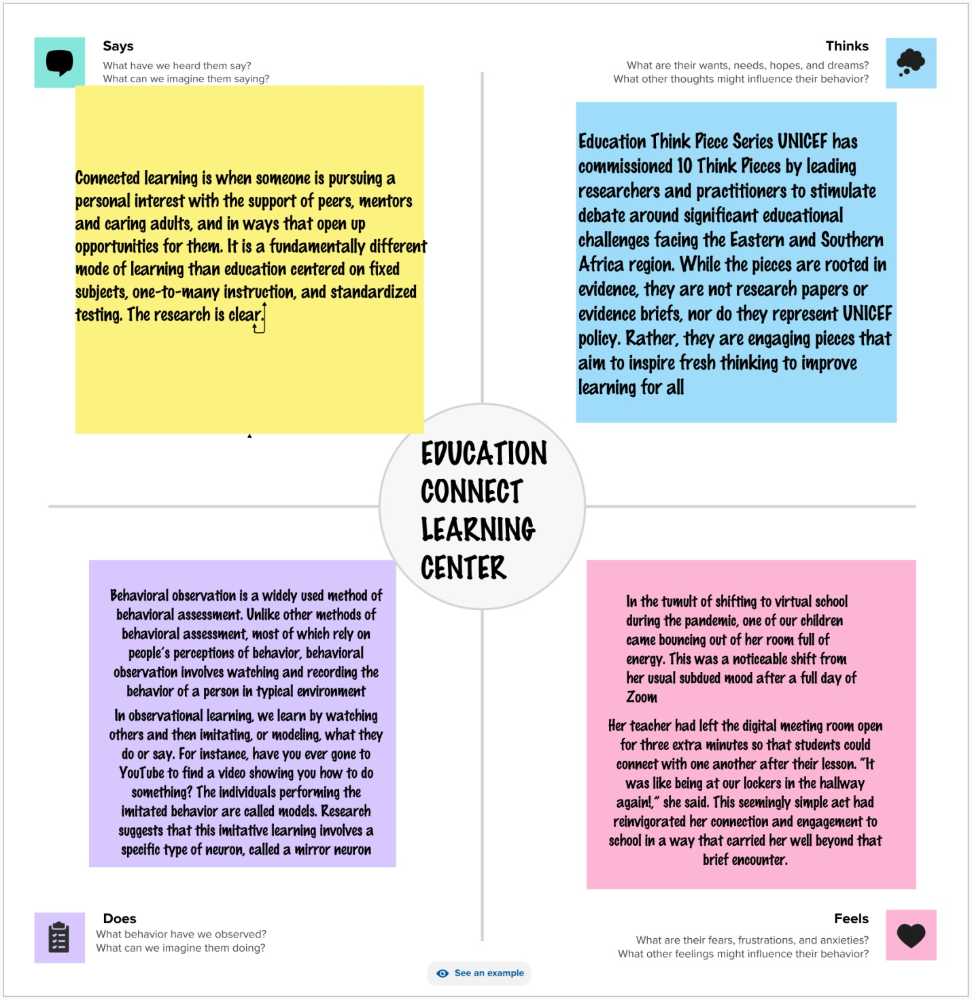

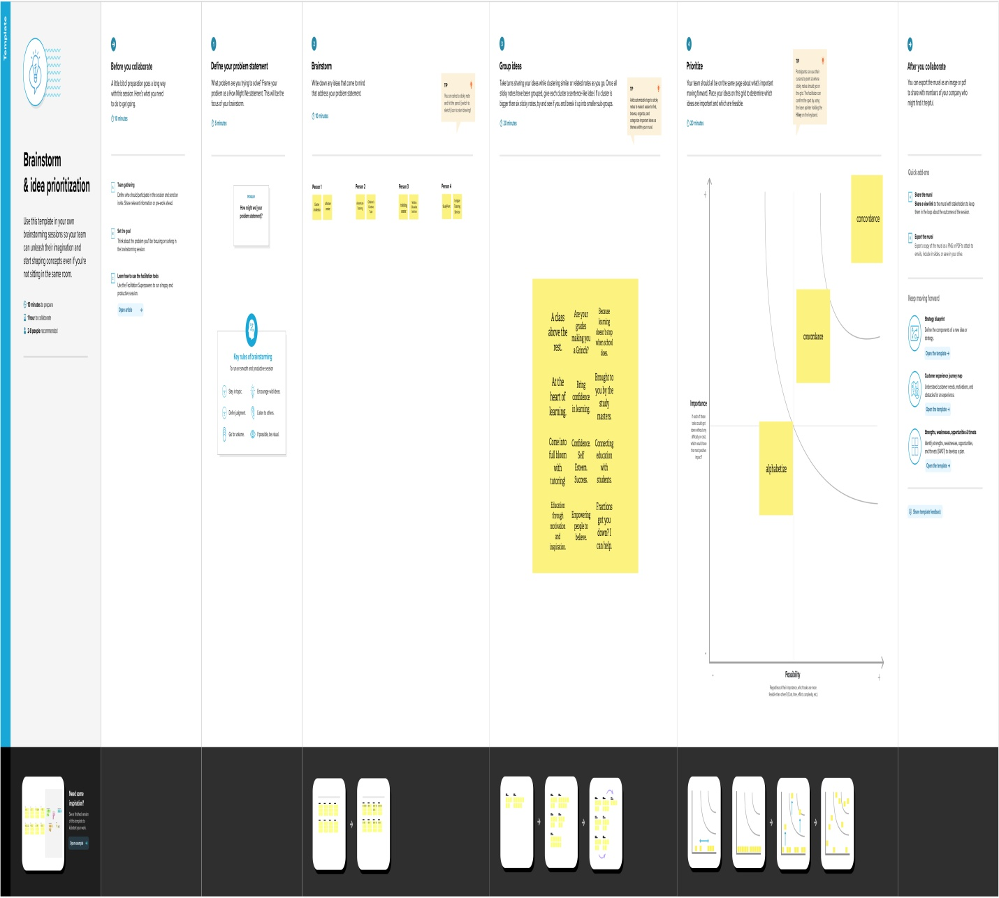

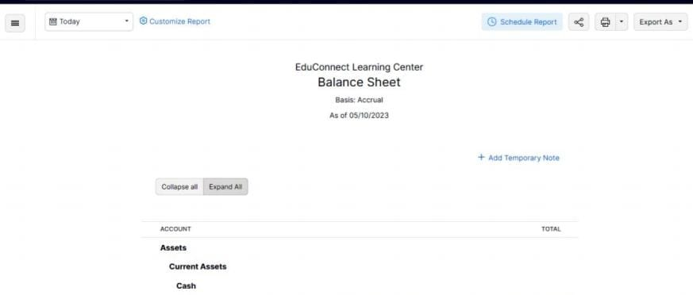

Result: Balance sheet and profit and loss accountof our project dream homes reality.

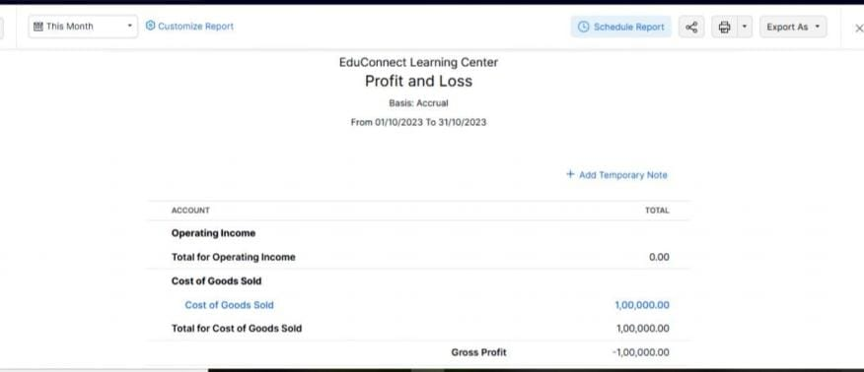

Profit and Loss

Basis: Accrual

Advantages of this concluding solutions:

The timing has never been better for using technology to enable and improve learning at all levels, in all places, and for people of all backgrounds. From the modernization of E-rate to the proliferation and adoption of openly licensed educational resources, the key pieces necessary to realize best the transformations made possible by technology in education are in place.

Educators, policymakers, administrators, and teacher preparation and professional development programs now should embed these tools and resources into their practices. Working in collaboration with families, researchers, cultural institutions, and all other stakeholders, these groups can eliminate inefficiencies, reach beyond the walls of traditional classrooms, and form strong partnerships to support everywhere, all-the-time learning.

Although the presence of technology does not ensure equity and accessibility in learning, it has the power to lower barriers to both in ways previously impossible. No matter their perceived abilities or geographic locations, all learners can access resources, experiences, planning tools, and information that can set them on a path to acquiring expertise unimaginable a generation ago.

All of this can work to augment the knowledge, skills, and competencies of educators. Tools and data systems can be integrated seamlessly to provide information on student learning progress beyond the static and dated scores of traditional assessments. Learning dashboards and collaboration and communication tools can help connect teachers and families with instantaneous ease. This all is made more likely with the guidance of strong vision and leadership at all levels from teacher-leaders to school, district, and state administrators. For these roles, too, technology allows greater communication, resource sharing, and improved practice so that the vision is owned by all and dedicated to helping every individual in the system improve learning for students.

Disadvantages of concluding solution:

Smartphones have a bad reputation in classrooms and there have been [strong cases for banning them in schools](https://www.oxfordlearning.com/should-cell-phones-be-allowed-classrooms/). Research suggests that during class time, when smartphones 42% of the time that students spent on their smartphones in the classroom, it was to text, tweet, or otherwise engage in social media rather than the lesson.

However, bans on devices such as smartphones are unlikely to work as students will inevitably get around them. Also, such bans would be resented by students, who consider the use of technology to be a matter of personal autonomy that should only be regulated when it distracts other students. While teachers can help students learn better self-control methods to help them to regulate their own use of devices, [research](https://ojs.lib.uwo.ca/index.php/cjsotl_rcacea/article/view/8002/6577) shows that better lesson plans that promote student engagement have less off-task use of technology.

Therefore, the onus is on instructors to create engaging, inspiring, and stimulating lesson plans that incorporate technology. For example, smartphones can access educational apps that promote learning as well as time management.

Many teachers incorporate digital platforms into lesson plans and find that using social media can actually keep students engaged and encourage classroom participation. Some teachers even create twitter hashtags to encourage comments.

Technology can be used to supplement lesson plans with digital materials, including [video](https://www.viewsonic.com/library/education/effective-educational-videos/), news stories, online discussions, and to encourage participation. Get creative!.....

Application:

The application where we used to solve those problems are as follows;

Github :

A GitHub repository can be used to store a development project. It can contain folders and any type of files(HTML, CSS, JavaScript, Documents, Data, Images). A GitHub repository should also include a licence file and a READMEfile about the project. Zoho books :

Online accounting software used to manage and built your business. Zoho Corporation, is an Indian multinational technology company that makes computer software and web-based business tools. It is best known for the online office suite offering Zoho Office Suite.

Conclusion :

As per the economic survey 2017-18, India will require USD 4.5 trillion by 2040 for the development of infrastructure. The housing and township development sector has received USD 24.7 billion till 2017 through the FDI route. Moreover, backed by the implementation of the goods and service tax (GST) logistics sector is expected to reach USD 218 billion by 2020 from USD 160 billion in 2017. Various factors such as the current scenario of infrastructure that is inadequate to sustain the urban population, government new urban development mission and the partnership agreements between urban local bodies and foreign players are further expected to boost the growth of the India construction industry. Also, 100% FDI in construction development projects (housing, townships, hospitals, hotels, education institutes, etc.) and developing industrial parks is allowed through automatic route. Future scope: The size of India Construction market is around USD 639 billion in the current year and is anticipated to register a CAGR of over 6% during the forecast period.

● Top property developers are planning launches of plots close to major cities as they seek to exploit a surge in demand in this segment during the pandemic.Post-Covid, Indians have realized the need for bigger spaces and, more importantly, open spaces. Naturally plotted houses have more open & breathable spaces, compared to an apartment.

● Increase in population is demanding more space for accommodation, especially in tier 1 cities. To fulfill the demand, construction activities have been increased by both government bodies and private sector companies. In India, government is also emphasizing on the development of rural areas. These are the key factors that have been fueling the growth of the construction market.

● The commercial real estate sub-sector is positioned for development as people return to workplaces and businesses adapt to hybrid working arrangements.

Future Scope:

Opportunity and agency. The goal of education is to empower learners, both

individually and collectively. As societies continue to

change, education systems need to provide opportunities

for learners to develop the knowledge, skills, attitudes,

and values that enable them to realise their potential

throughout their lives – from early childhood to old age.

Learners need to develop a sense of responsibility to

actively participate in building societies, and the ability

to define purpose and take actions to achieve goals,

including realising their own learning. Learners will need

to ability to design their own learning trajectories. As

such, developing agency over one’s life and learning is

itself an educational outcome that will equip learners

to thrive in a changing world. This puts the development

of broader transversal skills, as well as attitudes, values,

entrepreneurship, critical thinking, and metacognitive

skills, at the same level as traditional disciplinary

knowledge.

However, learners will need guidance and support

to exercise agency. They will need to be confident that

learning environments will recognise their prior learning

enabling them to reconnect with institutional and

informal learning seamlessly. In view of the pressures

to foster equity and inclusion in education, they also

need new, innovative support given their diverse social,

cultural, and ethnic backgrounds.

Professional educators

Autonomous, self-directed, technology-supported

learning will become more prevalent in the future.

Nevertheless, learning is a social experience that happens

through interactions. Therefore, education systems need

to better recognise, enable, and articulate the roles and

functions of educators, whether they are teachers,

trainers, coaches or other professionals in workplaces,

or tutors and peers.

In formal education teachers are professionals who

design and engineer learning environments and learning

processes, and support learning through a variety of

professional interventions. They need deep knowledge

and understanding of the content that they teach and how

learning happens. But they also face increasing demands

to use and interpret ever more sources of data and keep

ahead of the curve on rapidly developing teaching and

facilitation tools and techniques as well as supporting

learners in their well-being. Developing teaching as a

profession is an important public policy objective. This

includes recruiting and retaining effective teachers;

providing them with initial education and continuing

professional development; offering induction and

mentoring when entering the profession; establishing

attractive career structures with appropriate financial

compensation; regulating working conditions; and

safeguarding the attractiveness and reputation of, and

the social trust in, the teaching profession.

ZOHO BOOKS:

